Ссылка на книгу
http://wac.colostate.edu/books/young_teaching/young_teaching.pdf
Teaching Writing Across the Curriculum, Fourth Edition Prentice Hall Resources for Teaching Writing
By Art Young Digitized by the Colorado State University Libraries
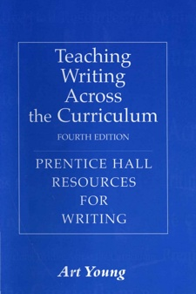

Teaching Writing Across the Curriculum, presented here in its fourth edition, provides a comprehensive, accessible discussion of teaching writing across the curriculum. Written by one of the leaders in the field of writing across the curriculum, it offers a brief introduction to WAC and then discusses how writing can be used to help students learn and communicate. Art Young writes that this book can "serve as a guide to teachers who have been assigned or who have volunteered to teach a required 'writing-intensive' course in their discipline as well as to faculty who themselves decide to include student writing. whether occasionally or frequently, in their courses." In addition to serving as a guide for teachers of WAC courses, this book also serves as an invaluable resource for faculty in English departments and writing programs.
Publication Information: Young, Art. (2011). Teaching Writing Across the Curriculum, Fourth Edition. WAC Clearinghouse Landmark Publications in Writing Studies: http://wac.colostate.edu/books/young_teaching/ Originally Published in Print, 2006, by Pearson Education, Upper Saddle River, New Jersey. Publication Date: May 1, 2011
Contact Information: Art Young's Home Page: http://people.clemson.edu/~apyoung/ Art Young's Email: apyoung@CLEMSON.EDU

